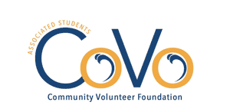
Reallocation Request

Please submit completed form to covo@as.ucsb.edu. If you would also like to request a reallocation of your project’s funds, you must submit a separate Budget Reallocation Request. You may contact us with any questions by emailing covo@as.ucsb.edu.
The Board will review your request at its next regular meeting and will notify you of its decision as soon as possible. Requests are not approved until voted on by the Board.
Project Title:
Today’s Date:
Project Number: (i.e. Fall 15-01):
Sponsoring Organization
Primary Contact Name:
Email:

Approved project end date:
Requested project end date:
Please briefly describe your project’s progress to date.

What obstacles have you encountered thus far?

Explain why you are requesting a reallocation of your project’s funds.

Please list approved allocation and newly- requested allocation.
ITEM DESCRIPTION | APPROVED ALLOCATION | REQUESTED ALLOCATION
TOTAL
Updated 202010

